## 

## 

## 

## 

## SIVA PRAKASH K

PRANAV R R

PRASANTH P

KAMALESH E

BHARATH SANKAR M

MAHARAJAN M

|  |  |
| --- | --- |
| SPARCHSCRIPT An Online Voice Based Mobile Prescription | |
|  |  |
|  |  |

**Contents**

1. Introduction
   1. Problem Statement
   2. Overview of the Project
2. Purpose
3. Objectives
4. Resources
   1. Budget
   2. Time
   3. Human Resources
5. Advantages
6. Website Breakdown Structure
   1. Design
   2. Working
   3. Technologies and Programming Languages used
   4. Testing
   5. Website Link and Hosting
7. Project Time
8. Cost Estimate
   1. Break down of cost
   2. Project Cost
9. Project Team
10. Literature Survey and Citations
11. Limitations and Threats
12. Conclusion

|  |
| --- |
| **1. Introduction:**    The need to improve health delivery services and provide efficient heartcare has resulted in a dramatic increase in the use of Information and Communications Technology (ICT) based solutions in the heartcare sector. Although the Internet has received significant attention in recent years, voice is still the most convenient  and natural way of communicating between human to human or human to computer. Voice technology allows a user to interact with the Internet through voice recognition technology by using a voice browser and /or the telephone. Voice-enabled systems are applicable in several areas including information providers such as stock, flight, financial institutions, customer services, e-Learning and a lot more.  Currently, the technology is mostly being used to perform online searches, with 60 percent of global regular voice tech users claiming to do so, according to the Speak Easy report. However, Ng’s comments suggest that with just 4 percent greater accuracy, the technology could play a far larger role in our lives. And with voice assistant ownership reaching new highs (Amazon’s best selling product across Thanksgiving and Christmas 2017 was its Echo Dot device), everything is in place for the technology to become far more ubiquitous.  On a broader societal level, voice promises to make interactions with technology more natural and human. The hope is that people will become liberated from being stuck behind a screen, helping them to become more present and in tune with our surroundings.  voice searches per month      **1.1 Problem Statement:**  A Doctor should be able to dictate his prescription to the patient while talking to his phone or PC running windows.   * Doctor will say one or more of keywords. * For all keywords data should be captured discreetly. * Doctor should be able to edit / delete by voice or hand any entry that has been made. * Doctor should be able to preview the prescription * Patient should get the PDF document either directly or as a link in SMS/WhatsApp     **1.2 Overview of the Project:**    As technology advances internet is becoming ever popular. Website has become an essential part. We have developed a website for the doctors so that the doctor can generate his e-prescription automatically by filling the prescription form through his/her own voice. We have designed the website in a very user-friendly interface with a login system for the doctors where they have to sign up with their clinic/hospital details and its authorized seal, their signature, etc. Once submitted, the doctor can then script any number of prescriptions to their patients without the need for re-filling their details again and again. After the filling of the form through voice or by hand the doctor can send the e-prescription to the patient with a single click. The doctor can generate any number of prescriptions. The generated e-prescription will be directly sent to the patient’s email-id.  **2. Purpose:**  Adverse drug effects are a major cause of death in the world with tens of thousand deaths occurring across the world each year because of medication or prescription errors. Many of such errors involve the administration of the wrong drug or dosage by care givers to patients due to indecipherable handwritings, drug interactions, confusing drug names etc. The adoption of voice-based mobile applications could eliminate some of these errors because they allow prescription information to be captured and heard through voice response rather than in the physician’s handwriting. This paper presents a design and implementation of a Voice-based Mobile Prescription Application (vbmopa) to improve health care services. The application can be accessed through a mobile phone by dialing an appropriate number. This system could lead to costs and life savings in healthcare centers across the world especially in developing countries where treatment processes are usually cumbersome and paper based.  See the source image  **3. Objectives:**  The objective of this paper is to design and develop a voice-based mobile prescription application (vbmopa) that offers an alternative e-health platform to complement the existing mobile healthcare delivery system. Voice- based mobile prescription system is a system of healthcare delivering services that can take place anytime, anywhere with the help of a mobile phone by dialing a telephone number that connect users to an e-prescription application that is resident in a web server.  **4. Resources:**    The following are the resources utilized by us that helped to build this  Project.  **4.1 Budget:**  8,000 Indian Rupees  **4.2 Time:**    110 days but not more than 3 months  **4.3 Human Resources:**   * Project Manager   **Prashanth P**  Mob: +919361571318   * Front-end Developer   **Pranav R R**  Mob: +7904936748   * Back-end Developers and Hosting:   **Kamlesh E**  Mob: +919361194577  **Siva Prakash K**  Mob: +919344015965   * Communications and Database Management   **Bharath Sankar M**  Mob: +919360546976  **Maharajan M**  Mob: +916382882596      **5. Advantages:**  For Doctors:   * Doctors can seclude themselves from exhaustive writing and thus saving their time. * The website allows the doctors with sign up and login options to manage their account effectively with all abilities to edit, add or delete their profile. * The doctor can avoid direct-contact with the infected patients thus minimizing their risk of contamination of infection. * The doctor will be able to send the e-prescription directly to the patients through his email.   For Patients:   * Patients can get medication easily from the doctor while sitting in home. * No need of confusions due to the doctor’s indecipherable handwriting like in the normal handwritten prescriptions. * The patient will not have any risks of health issues because of getting wrong medications due to incomprehensible prescriptions. * The patient will be receiving the e-prescription to his e-mail. * The e-prescription in PDF will be accessible by the patient anytime he wanted. |

**6. Website Breakdown Structure:**

**6.1. Design:**

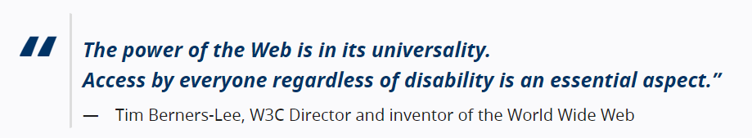

Accessibility is essential for developers and organizations that want to create high-quality websites and web tools, and not exclude people from using their products and services. The Web offers the possibility of unprecedented access to information and interaction for many people with disabilities. That is, the accessibility barriers to print, audio, and visual media can be much more easily overcome through web technologies.

Accessibility supports social inclusion for people with disabilities as well as others, such as:

* older people
* people in rural areas
* people in developing countries

We have designed our website accessible for screen readers that allow blind or visually impaired users to read the text that is displayed on the computer screen with a speech synthesizer or braille display. A screen reader is the interface between the computer's operating system, its applications, and the user.

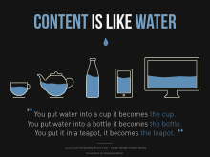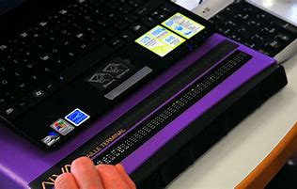

Another important accessibility of websites is Responsive Web Design(RWD). It  is an approach to web design that makes web pages render well on a variety of devices and window or screen sizes. We have designed our website responsive for all mobile phones, tablets and PCs.

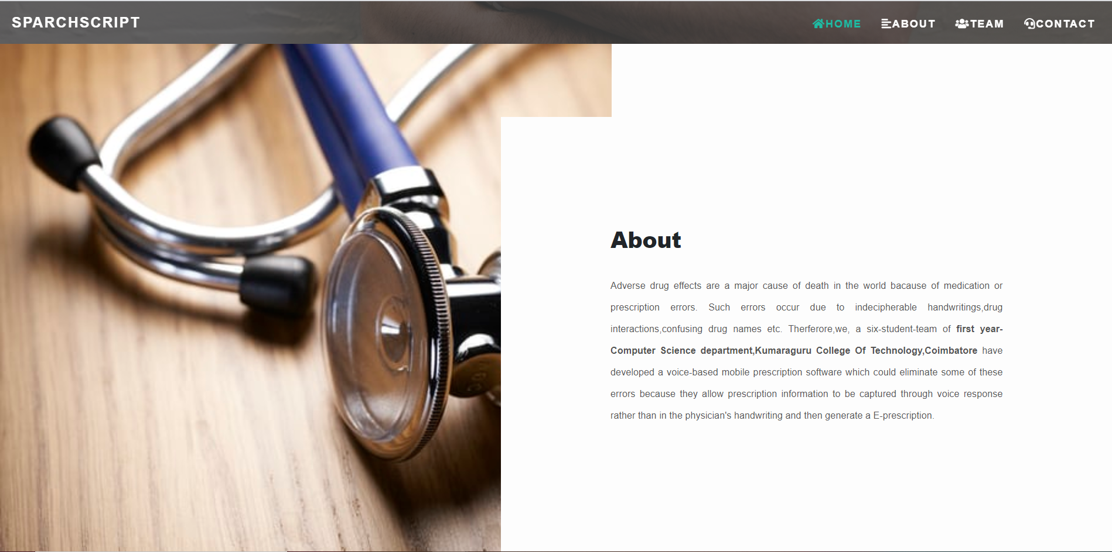

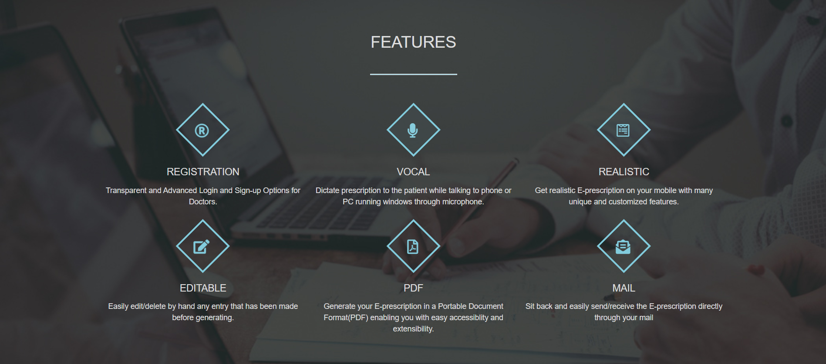

A Look of our website in a PC or desktop

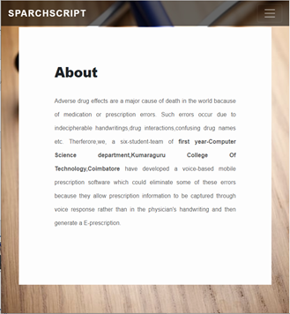 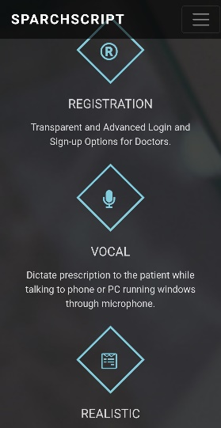

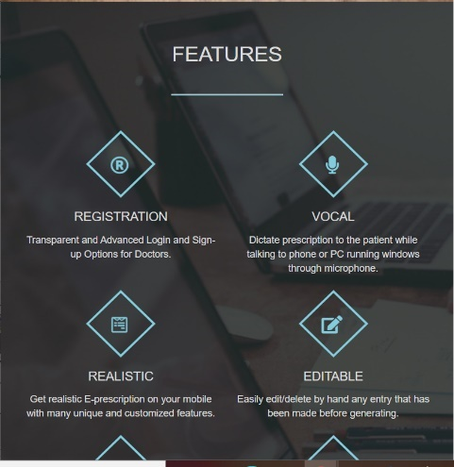

A Look of our website in a mobile phone

A look of our website in a Tablet

**6.2. Working:**

The first page of our Website is the Sparchscript-Home Page with all the details of the website, its aim, project team, contact and the about section. The page will lead the user to select Sign up or Login option depending on his account availability.

**HOME PAGE**

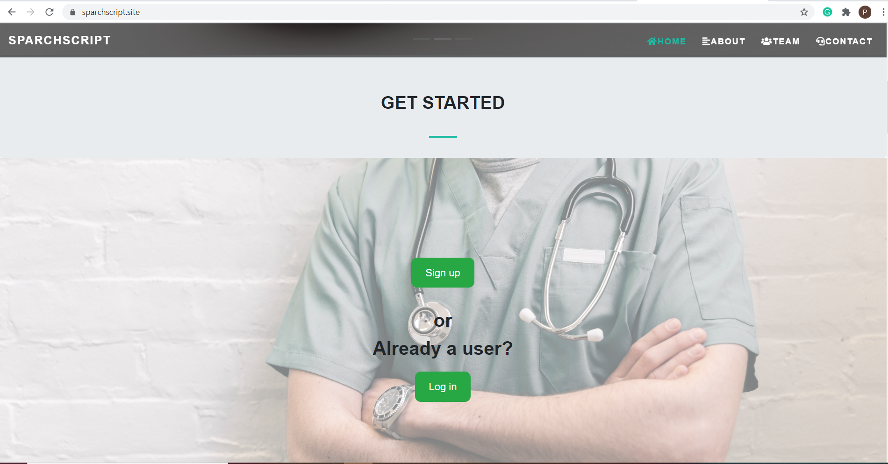

The Sign up will get all the details of the doctor and his clinic. After account verification through e-mail, the page will prompt the user to upload his clinic seal and his signature. They will be always present in the e-prescription whenever, the doctor generates the prescription to his patients. If the user has an account already, then he/she can login by using his/her username and password.

**LOGIN PAGE**

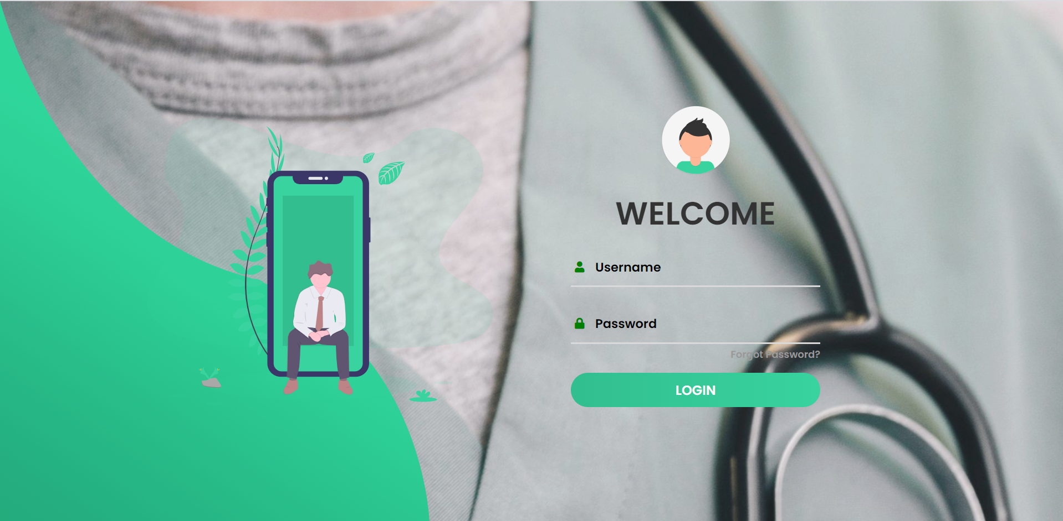

**SIGN UP PAGE**

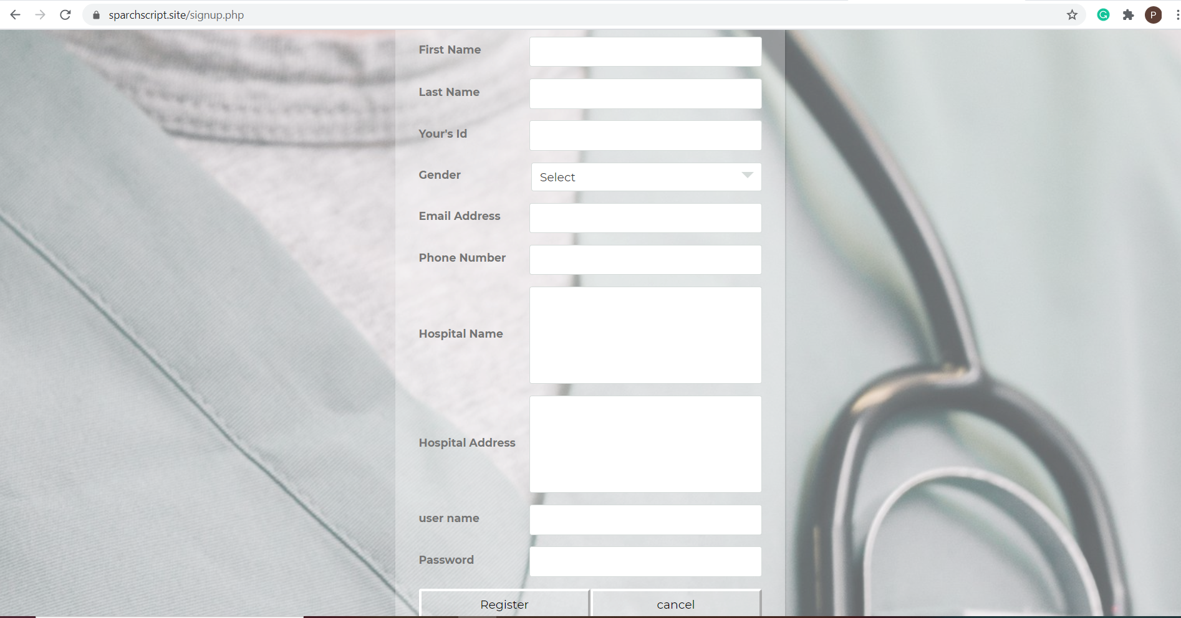

After the registering through the sign up page, the user have to verify his account by entering the verification code sent to his e-mail. The doctor has to then upload his signature and seal.

**VERIFICATION PAGE**

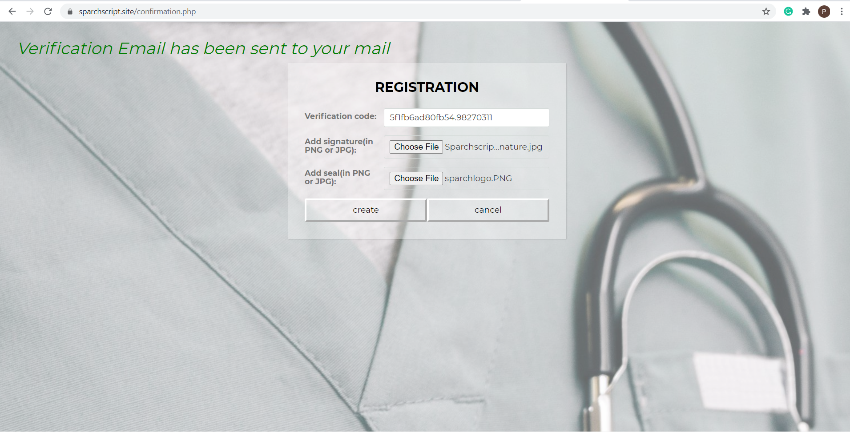

**USER PAGE**

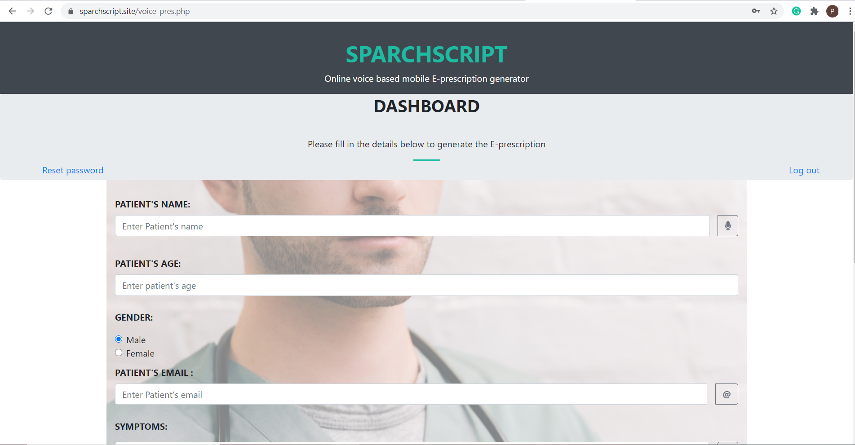

The user page provides the interface for the doctor to generate the prescription by filling the form through voice by clicking on the little “mic” button next to the fields. The form includes every feature of a real-world prescription. The doctor can add any number of diagnosis and prescription fields he wishes to add. The doctor can also edit his entry by this hand.

Also, the page provides an option for the user to logout of his account, reset his password, update his profile and also delete his account easily and comfortably.

**PRESCRIPTION FORM**

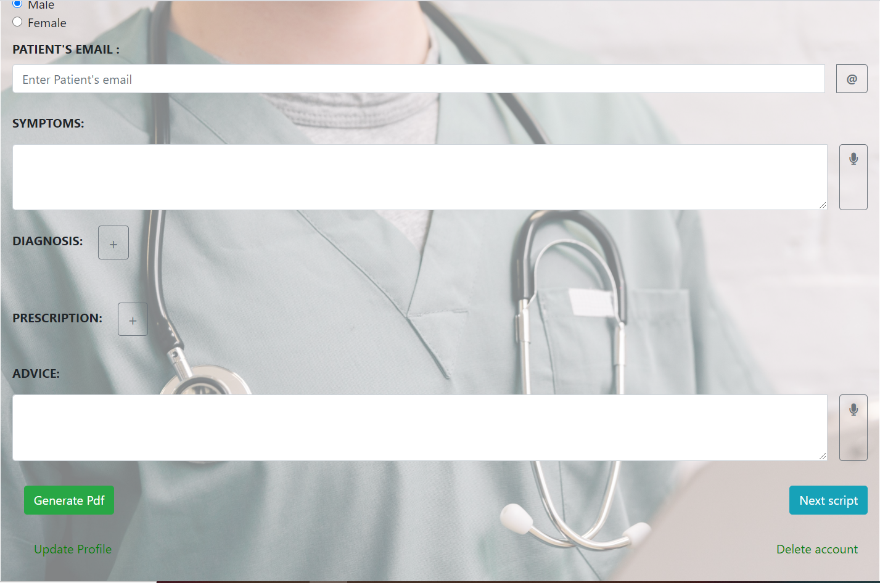

The prescription will be directly sent to the patients’ email addresses after clicking on “Generate Pdf” and the doctor can click on “Next Script” to generate the next prescription.

**EXAMPLE OF E-PRESCRIPTION SENT TO THE PATIENT**

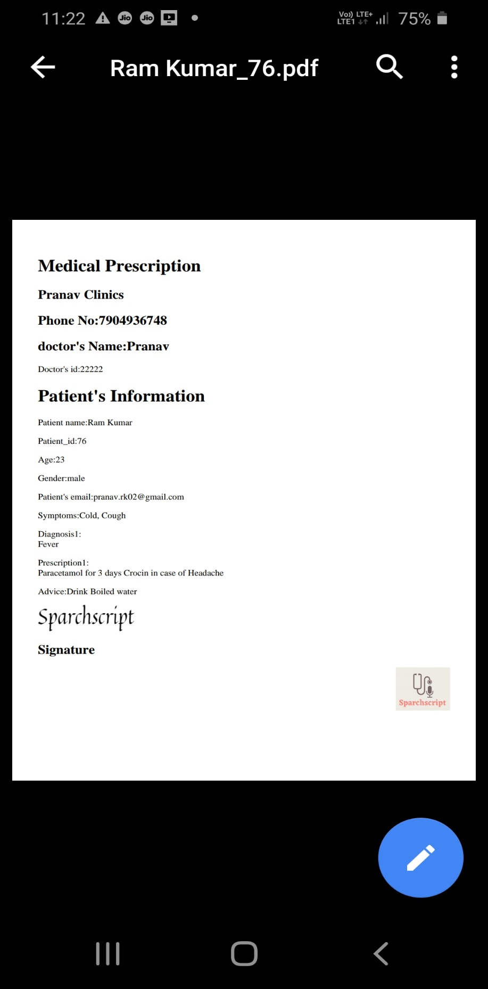

The generated e-prescription will be directly sent to the patient through his e-mail address in PDF making it more accessible and extensible for the patients.

**6.3 Technologies and Programming Languages used:**

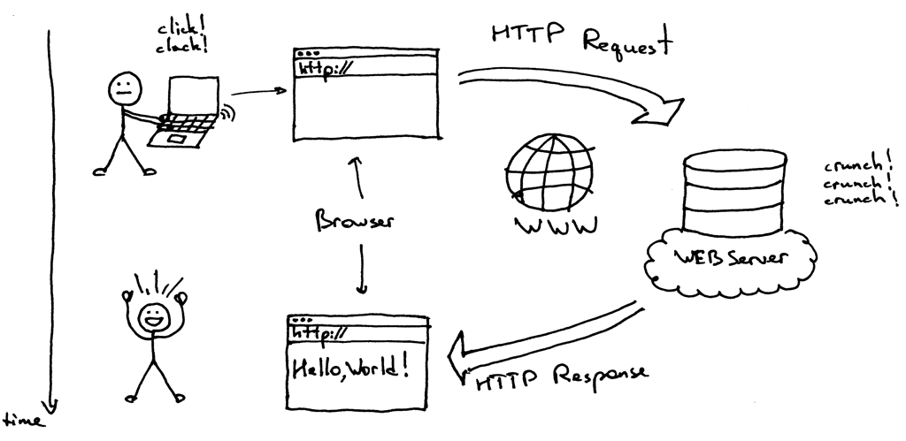

 

Bootstrap 5 for Responsive Web Design HTML 5 and CSS 3 for client side designing



*Javascript and Jquery for interactive front-end design*



*PHP and MySQL for backend development*

**6.4 Testing:**

* Functionality test
* User Interface Main Site
* Security Test
* Speed test
* Web traffic & Load traffic
* Speed Test

**Login Credentials**:

To quickly test our product, login through our dummy account using the following login credentials.

**User Id:** Sparchscript

**Password:** Sparch@0509

**6.5 Website Link and Hosting:**

Website link: <https://sparchscript.site>

Website hosting Services: <https://infinityfree.net>

**7. Project Time:**

The project is estimated to finish in 110 days. For the purpose of buying a domain and hosting services the deadline was extended to 120 days. We completed our project within three months.

**8.Cost Estimate:**

The BUDGET cost of the project was around 8,000 INR. The following table contains the breakdown of the cost.

**8.1 Breakdown of cost:**

|  |  |
| --- | --- |
| **Cost Item** | **Amount** |
| 1. Learning various courses online | 3000 INR |
| 2. Web Domain | 500 INR |
| 3. Hosting Services | 2500 INR |
| 4. Other expenses(network,etc) | 1000 INR |
| **Total** | 7000 INR |

**8.2 Project Cost:**

The original total cost of the project was around 7000 INR.

**9.Project Team: Team 8 of Engineering Clinics**

* Siva Prakash K 19BCS073
* Pranav R R 19BCS065
* Maharajan M 19BCS089
* Kamalesh E 19BCS084
* Bharath Sankar M 19BCS076
* Prashanth P 19BCS117

**10. Literature Survey and Citations:**

**Abstract:**

An automated prescription transcription and dispatch service using voice recognition and a customizable, user-friendly telephony interface is provided. Doctor or other medical personnel can call a prescription services system, and provide spoken prescription information. The call can be placed directly to the prescription services system using the Public Switched Telephone Network (PSTN) or Voice-over-IP (VoIP) connection, or can be forwarded to the prescription services system from a telephone number corresponding to a pharmacy. The system prompts the user through audible menus to provide prescription and patient information. The spoken information is digitized, recorded, and stored in the prescription services system, and then transcribed into textual format. The transcribed prescriptions are then transmitted to the doctor or medical personnel via variety of communication methodologies, such as fax, e-mail, XML, and electronic data interchange, for confirmation, review, and record keeping purposes. Further, the transcribed prescriptions are transmitted to a pharmacy, using similar communication methodologies, for review and further processing. The caller can call the prescription services system to review the spoken and transcribed prescription information stored from a previous session. The prescription services system can be integrated into existing pharmacy management systems using electronic data interchange (EDI) and other data exchange protocols.

**BACKGROUND OF THE INVENTION**

*1. Field of the Invention*

The present invention relates to a method and apparatus for providing prescription services. More specifically, the invention relates to a method and apparatus for providing prescription, prescription refill, transcription, and forwarding services using voice recognition software and associated computer hardware.

*2. Related Art*

In the medical profession, doctors and other medical personnel frequently prescribe drugs and other medicines for their patients. Traditionally, such prescriptions are recorded by the doctor on paper, and are given to the patient for filling at a local pharmacy. Additionally, doctors frequently call pharmacies to place prescriptions, which may later be picked up by the patient. Both written and telephonic prescriptions require the prescribing doctor or the pharmacy to write down prescription information, thereby delaying the refill process and requiring time and effort on the part of such personnel. Further, the refill process is hindered by transcription errors that may occur when pharmacy personnel transcribe a doctor's telephoned prescription, or when the pharmacist is required to read a doctor's unintelligible handwriting. Finally, when prescriptions are manually transcribed, there is no efficient way for a doctor to review a prescription once it has been recorded by the pharmacy.

Accordingly, it would be desirable to provide a system for receiving prescriptions from a caller over a telephone, transcribing same, and transmitting textual prescription information to pharmacies. Further, it would be desirable to provide a system for transmitting confirmation information to a doctor or medical facility, and which allows the caller to quickly and efficiently review prescription information.

**OBJECTS AND SUMMARY OF THE INVENTION**

It is an object of the present invention to provide a method and apparatus having voice recognition capabilities for receiving, transcribing, and forwarding prescriptions to pharmacies for filling.

It is an additional object of the present invention to provide a method and apparatus wherein prescriptions can be received from a doctor or medical personnel over a telephone and using voice recognition techniques, the prescription being transcribed and transmitted to a pharmacy for filling.

It is a further object of the present invention to provide a method and apparatus wherein prescriptions can be transcribed and transmitted back to a doctor or medical facility for confirmation or review prior to transmission to a pharmacy for filling.

It is still another object of the present invention to provide a method and apparatus wherein prescriptions can be stored centrally or locally, and later retrieved.

It is a further object of the present invention to provide a method and apparatus wherein a caller can be prompted to provide prescription information through customized, audible menus that can be accessed by a telephone.

It is still another object of the present invention to provide a voice recognition prescription services system that can be customized to include a variety of audible prompts.

It is a further object of the present invention to provide a voice recognition prescription services system that can receive prescriptions from telephone calls from doctors.

It is yet another object of the present invention to provide a prescription services system that can receive prescriptions forwarded from a pharmacy telephone number, unbeknownst to a caller.

**Citations and References:**

[1] Palo Wireless, VoiceXML resource center, 2007: available online at

http://www.palowireless.com/voicexml/tutorials.asp, accessed 19th March

2009

[2] Meyer G.(2008), “Voxpilot a eureka software company”, benefits of VoiceXML, 2008

[3] Azeta A. A., N. A. Ikhu-Omoregbe, C. K.Ayo & A.A. Atayero (2008), “Development and Deployment of VoiceXML-Based Banking Applications”, Journal of Computer Science & its Application, An Internationa l Journal of the Nigeria Computer Society (NCS), Vol. 15 No.1 June Edition, pp. 59-72

[4] Atayero A. A, Ayo C. K. Ikhu-Omoregbe N.A, Azeta, A. A. (2009), “Implementation of‘ASR4CRM’: An Automated Speech-Enabled Customer Care Service System”, IEEE Xplore. 2009. Eurocon’09 IEEE International Conference, Saint-Petersburg, Russia. May 18 – 23 2009. pp. 1712-1715. Program Available online at: [www.ewh.ieee.org/r8/russia/nw/cem/eurocon2009/f iles/Schedule/May_20_Schedule.doc](http://www.ewh.ieee.org/r8/russia/nw/cem/eurocon2009/f%20iles/Schedule/May_20_Schedule.doc)

[5] Azeta A. A., Ayo C. K., Atayero A. A. and Ikhu-Omoregbe N. A. (2009), A Case- Based Reasoning Approach for Speech- Enabled e-Learning System”, 2nd IEEE International Conference on Adaptive Science & Technology (ICAST), Accra Ghana.

[6] Anita M., Maria J., Gunvor G., ((2005), The MobiHealth Usability Evaluation Questionnaire, eHealth International Journal, 2005. Retreived July 2009 from http://www.ehealthinternational.org/vol2num1/ Vol2Num1p09.pdf

[7] W. Kim (2007), “Towards a Definition and Methodology for Blended Learning”, Blended Learning, pp. 1-8, Pearson, 2007. Workshop on Blended Learning ‘07, U. K.

**11. Limitations and Threats:**

* The team isn’t a registered organization
* Lack of Human Power
* Relatively less experienced team
* No initial hosting space for testing
* Possibility of domain frauds
* Price hike of components required

**12. Conclusion:**

The voice-based mobile Prescription application (vbmopa) discussed in this paper, allows physicians with mobile phones devices within a telephone network coverage capture and view patients’ medication details. This is a step toward enhancing the efforts being made to avoid problems of prescriptions by care providers. The access to the patient’s medical records real-time improves patients’ care by ensuring that correct information such as the appropriate medication to be administered is retrievable. In addition, the application improves efficiencies of health care services by eliminating time-consuming call-backs that may be associated with treatment processes.